Welsh Government have reviewed the processes and systems around Additional Learning Needs (ALN). There will be new legislation in place from September 2021, which will be in full implementation from September 2024. There are changes that may impact you and your child.

**SEN TO ALN**

We will be using the term ‘Additional Learning Needs’ rather than ‘Special Educational Needs’. All Local Authorities will have an Early Years ALN lead officer to support children in Early Years settings.

Children or Young People have an Additional Learning Need when:

-They have a significant difficulty or disability that means they need targeted and sustained support; i.e. Additional Learning Provision.

-They find it much harder to learn than children or young people of the same age nationally;

-They have a disability that means they cannot use their local school or college.

YOUR CHILD AND THE ALN ACT 2018

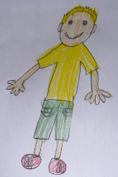

Belief in an inclusive and equitable system where the needs all of can be met to ensure successful, independent and resilient children and young people.

A rights-based approach where the views, wishes and feelings of children, young people and parents are central to the planning and provision of support; and are enabled to participate as fully as possible in the decision-making process.



**Claire Gratton ALNCo**

**01633 647488**

**Claire.gratton@wcp.schoolsedu.org.uk**

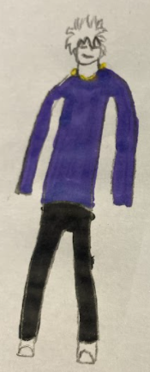

# Torfaen County Borough Council - My Council Services

**0-25 YEARS OLD**

Children or Young People with ALN will have one system of support from the age of 0 to 25 years old.

**DISAGREEMENT RESOLUTION AND RIGHTS OF APPEAL**

Whenever possible, disagreements will be dealt with as quickly as possible with the LA and the key people involved.  
An appeal is when you request that a decision be changed.  
Independent support groups will be able to listen and help if there are disagreements which cannot be resolved. Children, young people, parents and carers have the right to appeal decisions made by the school and the Local Authority about the child or young person’s additional learning needs or additional learning provision.

# PARTICIPATION OF CHILDREN AND YOUNG PEOPLE

What children and young people think, feel and would like will be central in our planning. The children and young people will be part of developing their Individual Development Plans.

**COLLABORATION**

The thoughts, feelings and wishes of parents andcarers will be gathered as an on-going process. Where relevant Local Authorities andEarly Years Services will work with health, social services and anyone else who supports the child or Young Person.

# UNIFIED PLAN (INDIVIDUAL DEVELOPMENT PLAN)

Children or young people identified as having an ALN and require additional learning provision will have an Individual Development Plan (IDP) to show their needs and the support in place.

***Additional learning provision is support which is additional to that provided to the majority of children or young people of the same age.***

The IDP will include the advice of a range of professionals supporting the child or young person (where relevant).

IDPs will be reviewed annually or when anything significant changes for the child or young person.

